Food in prison
Unit 1
Food and menus

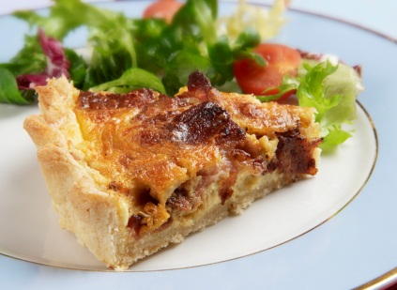

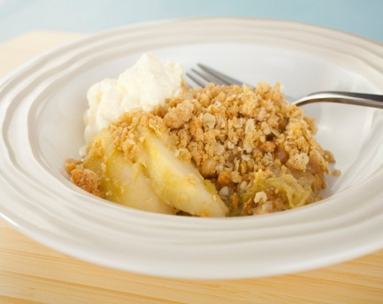

Contents

Unit 1 Food and menus teachers’ notes

Unit 1 Food and menus learner resources

Unit 1 Food and menus additional resources for teachers

Unit 1 Food and menus answers and transcript

Unit 1 Audio file: TP_FoodBuyinginPrison1_Unit1.mp3

Unit 2 Eating in prison: rules and requests

Unit 2 Eating in prison: rules and requests

Unit 2 Eating in prison: rules and requests additional resources

Unit 2 Eating in prison: rules and requests answers

Unit 3 Food in prison teacher’s notes

Unit 3 Food in prison learner resources

Unit 3 Food in prison answers

Unit 3 Video – What Do You Think of Prison Food?

Copyright - please read
All the materials on these pages are free for you to download and copy for educational use only in your establishment. You may not redistribute, sell or place these materials on any other website without written permission from the British Council. If you have any questions about the use of these materials please email us at: esolnexus@britishcouncil.org

Introduction

Overview
This teachers’ pack teaches the English language needed for understanding menus, becoming familiar with the kind of food available in prisons; for talking about managing money and for buying and ordering essential items while in prison.
Unit 1 helps learners to select from a menu;
Unit 2 introduces vocabulary and structures to do with prison rules and asking for food items;
Unit 3 focuses on learners describing and talking about food in prison.

Level: Entry level 1-3 / Scottish National 2 – National 4 / CEFR A1 - B1

Structure, learning hours and delivery context
- The resource is divided into 3 units:
Unit 1 Food and menus
Unit 2 Rules and requests
Unit 3 Eating in prison
- The resources developed for each unit may be used independently or together with the self-access Eating in Prison workbooks.
- It takes a whole language approach but focuses on making key language related to food understandable in a prison context.
- Timings are flexible: teachers should adapt the resource to suit their learners and build in revision as required and can break down the units into smaller chunks of learning and build in revision as required.
- The resource is suitable for male and female offenders learning ESOL in prisons.

Unit 1 Food and menus - teacher’s notes
The food language items in this lesson are based on a sample menu from a prison in south-east England. It focuses largely on food items common in Britain that may be unfamiliar to those who have not lived long in the UK or who predominantly eat food from their own home country.
Time: Approximately 90 minutes (more with extension activities)
Aims
- To introduce lexis associated with food and prison menus.
- To talk about food from different countries (and thereby promoting cultural awareness and understanding).
Objectives
All learners will be able to:
- read and understand the names of some common dishes on a prison menu
- talk about meals in their country
- write and talk about their ideal prison menu.
Higher level learners will be able to:
- recognise some common collocations about eating and meals
- write their own menu
- write a letter of complaint.
Preparation
You will need:
- Resource 1: sample menu text. If the menu in your prison is different to the sample menu text, this can be edited
- Resources 2 and 3: a set of picture/ word cards to be copied and cut up for each pair/ group of learners. Key words and pictures can be substituted if you have changed the menu in Resource 1
- Resource 4: true / false quiz cards – one set per group
- Resource 5: one copy for each learner – you could copy the relevant day
- Resource 6: one copy of one day of the week for each learner. If copying is a problem, replace sheets with learners writing the details on their own paper
- Resource 7: picture cues to display on board or one large copy
- Resource 8: audio file - TP_FoodBuyinginPrison1_Unit1.mp3
- Resource 9: transcript of audio
- Resource 10: one per learner or pair of learners for early finishers

Suggested Procedure
Warmer: Learners talk about what they had to eat the day before (10 minutes)
- Introduce the topic by eliciting what learners had to eat the previous day. This can be done as a whole class or better still, in pairs/ threes.
- You might want to give an example yourself briefly first and elicit some useful language as a starter e.g. ‘For breakfast I had..’. If your class need it, write useful phrases on the board.
- At this stage let the learners know what they will be learning in the lesson.
Activity 1: Input – read menu text and match pictures to the menu items (15 minutes)
- Hand out resource 1. Find out first if learners have difficulty reading items on the menu. Discuss the menu and elicit the meaning of unfamiliar words.
- Hand out the picture and word cards (resources 2 and 3) and ask learners to match them, guessing any items that are not known. This can be done in pairs or small groups.
- Give the correct answers and discuss in more detail any words which need greater explanation. Make sure learners can say the words and deal with any pronunciation issues here.
- If desired, the picture card page can be used as a handout and the key words can be copied underneath the pictures.
Differentiation
For higher level learners see give the picture cards without the words.

Activity 2: Practice – True / False team quiz (15 minutes)
- Split the class into two teams and hand out six cards from resource 4 to each team.
- Check that everyone understands ‘True’ and ‘False’ by demonstrating using a card.
- In turn, a team reads a statement about a food item and the opposite team has to guess if the statement is true or false. Points are awarded for guessing correctly.
- Answers are also provided on the statement cards.
Differentiation
- Lower level learners: use the first six cards which are the easiest.
- For literacy learners, pair them with someone with higher level reading.
- Group beginners together and support them to understand and match with the picture cards from resource 2.
- There are blank cards for you or more advanced learners to add statements about food items in their prison.

Activity 3: Practice – oral information gap activity (15 minutes)
- Hand out resource 5. Ask learners to create their own menu for one day of the week first, taking ideas from the original menu options, writing in one sandwich option, one main course and a dessert.
- Elicit from learners suitable language to ask and answer about each other’s menus, e.g. ‘I’m having … for lunch’ ‘What are you having for dinner?’
- Learners then use the blank Monday to Friday menu (resource 6) to populate the menu for each day by asking the information from other learners.
- Monitor activity and feedback a few common errors at the end of the activity.
Differentiation
- For higher level learners, ask learners to write more than 1 day’s food items.
- If levels of literacy are low and this activity will take an undue amount of time, it can be done as a purely oral activity. Dispense with the blank menu sheet; instead, learners ask others the question (What’s on the menu on ....?) but only listen to the response rather than also recording it on their resources. They can then feed back to the whole group.
Activity 4: Listening - two prisoners talking about food in their countries (15 minutes)
- Firstly, introduce the task and show the three pictures of key vocabulary from the listening text (resource 7). Elicit the names and supply any vocabulary and concepts required.
- Before listening to the dialogue the first time, ask gist questions, e.g. Which countries do you think the two men come from? What meal times do they talk about?
- Before listening for the second time give a more detailed listening task such as: ‘List as many of the foods as you can’, ‘Write down two foods and two drinks you hear’, ‘What does the first speaker eat/drink?’
Differentiation
- These tasks can be differentiated by outcome, choosing the most suitable of the above tasks according to the group.
- Grade questions, giving different tasks to different groups of learners within your class.
- Listen again with the audioscript (resource 9).
Activity 5: Freer practice – talking about food from their own country (15 minutes)
- Learners are going to talk about food in their country. Elicit some types of food from learners’ countries for various meals. Ideally, prepare pictures of food from your learners’ countries.
- Elicit appropriate questions and answers. Model a possible conversation with a confident learner.
- To support learners, you could write a table like this on the board as you elicit:
Person A |  | Person B
normally/ for breakfast/ where you/ from |  | We/ I have …. / What about?
We/ I have …. / lunch? |  | We/ I have …. / And you?
We/ I have ….. and …. / dinner |  | We/ I have …. / And you?
We/ I have …. / What/ favourite food? |  | My favourite …. / What about… ?

- Remind them to include fillers such as well/ so/ then.
- Also adverbs of frequency such as normally/ usually/ often/ sometimes.
- Group learners with those of a similar level as they will then be able to work at their own level.
- Monitor and provide any vocabulary that learners might need to talk about food specific to their country.
Extension/ differentiation
- Group pre-entry learners together. Once other learners are speaking, use photos to elicit food from their country and ask them questions as appropriate. Drill and get them to ask their partners.
- For stronger learners include more phrases e.g. ‘Do you have 3 meals a day? What’s …. (e.g. injera)? It’s a type of flat bread we eat with meat.’
- If the table on the board would not work with your group, create some cue cards e.g. ‘What/ eat for breakfast/ your country?’
- Early finishers can complete the phrases collocation extension resource 11.
Cooler: Oral feedback (5 minutes)
- Ask learners to feedback about food in countries other than their own with the whole group.
Follow-up activities or extension activities
- Write their own ideal weekly menu incorporating food from their own country and other food they like.
- Put the menus around the room and ask the learners to vote for the best, giving reasons for their choice.
- Learners could write a letter of complaint about the food in their prison to Inside Time (see Inside Time letter Lesson Plan for more on this).
Resource 1: Example menu

Day  Tuesday 4th | Lunch  Sandwiches:  1. Tuna and mayo with sweetcorn  2. Cheese and pickle  3. Ham salad  4. Beef | Dinner  1. Cottage pie and mixed vegetables  2. Pork pie salad  3. Grilled chicken, mashed potato and cauliflower  4. Vegetable quiche, salad and coleslaw  5. Apple crumble and custard  6. Fresh fruit

Resource 2: Word cards to cut up.
custard | pork pie | pickle
quiche | cottage pie | apple crumble
coleslaw | chicken | pasty

Resource 3: Picture cards to cut up

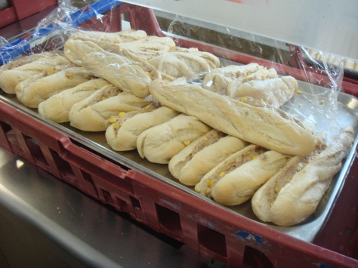 | 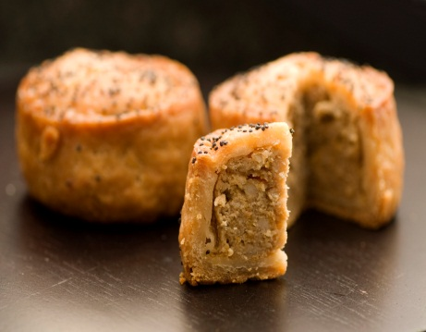 | 
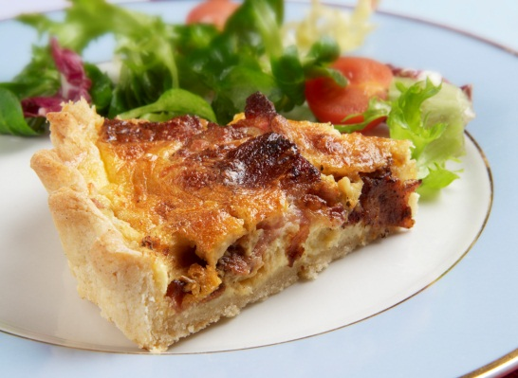 | 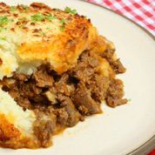 | 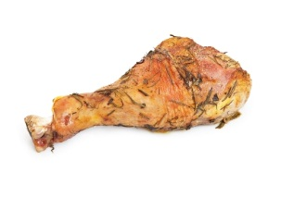
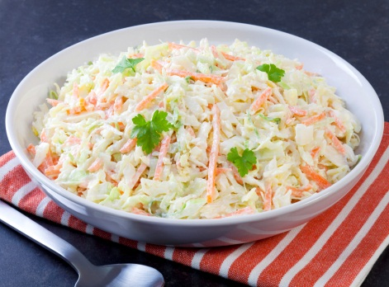 | 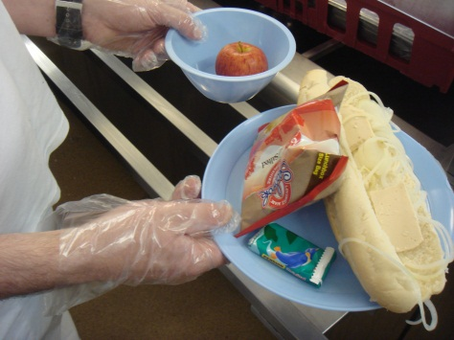 | 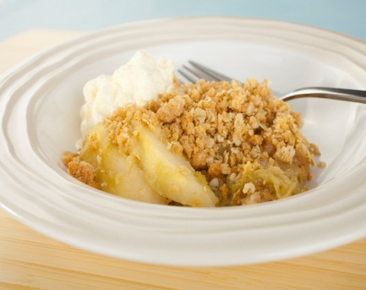

Resource 4: True / False quiz cards
custard  is brown  (False: it is yellow) | apples  are fruit  (True) | chips  are sweet  (False: they are savoury)
beef  is goat meat  (False: it is meet from cows) | apple crumble  is a pudding  (True) | sardines  are fish  (True)
bacon  is beef  (False: it is pork) | a pasty  is made of pastry  (True) | cottage pie  has mashed potato on top  (True)
pickle  is made with meat  (False: it is made with vegetables) | cottage pie  is made with beef  (True) | custard  is salty  (False: it is sweet)
coleslaw  is made from carrots and potatoes  (False: it is made from carrots and cabbage) | apple crumble  is apple with bread on top  (False: It is apple with a butter, sugar and flour mix on top) | quiche  is made with eggs, and cheese  (True)
a pork pie  has vegetables in it  (False: it is only pork in pastry) | lasagne  has cheese in it  (True) | sandwiches  are made with pastry  (False: they are made with bread)
Write here | Write here | Write here
Write here | Write here | Write here
Write here | Write here | Write here

Resource 5 Your menu
Write your menu for one day: one sandwich, one main course, one dessert.

Monday | Tuesday | Wednesday | Thursday | Friday
For lunch  For dinner | For lunch  For dinner | For lunch  For dinner | For lunch  For dinner | For lunch  For dinner
Resource 6 Your classmates’ menus
Monday | Tuesday | Wednesday | Thursday | Friday
For lunch  For dinner | For lunch  For dinner | For lunch  For dinner | For lunch  For dinner | For lunch  For dinner
Ask your classmates what food is on their menu this week. e.g. ‘What’s on the menu on Wednesday?
Resource 7: Picture cues
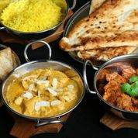 | 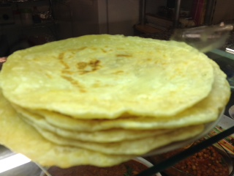 | 

................................................................................................................................................

Resource 9: two prisoners talking about food in their home countries

A: So what do you normally have for breakfast where you come from then?
B: Well, we don’t eat breakfast cereal like here. We often have eggs and roti, which is like bread, and some fruit maybe, usually with a cup of tea. And what about you?
A: Yeah, we eat bread too but with different types of cheese and meat usually. We drink mainly coffee not tea. What about lunch? What do you have?
B: Oh, rice and curry most days. What do you eat?
A: We have a big meal for lunch – soup, sausages or meat with salad and potatoes… something like that. What do you have?
B: Maybe rice and a different type of curry.
A: I love curry! It’s funny – it’s the national dish in the UK!
B: Yeah, I even make it for the men on the wing.

Resource 10
Can you match the two parts of the following phrases about food and menus?
Use a dictionary if some words are new. Write the letter (a, b, c ..) next to the words in the first column. Or write the correct words in the middle column.

1. cheese |  | - course
2. for |  | - skimmed
3. pork |  | - ketchup
4. corned |  | - and pickle
5. on the |  | - course
6. cottage |  | - breakfast
7. for |  | - cream
8. apple |  | - pie
9. semi |  | - pie
10. bread |  | - menu
11. salad |  | - lunch
12. tomato |  | - roll
13. main |  | - beef
14. second |  | - crumble

Food and Menus. Answer key.
Activity 4 Listening – gist & detail questions

Gist a) possible answers India, Bangladesh or Pakistan (B) possible answers are Poland, Spain, Moldova or Lithuania (A)
b) breakfast, lunch and dinner

Detail a) and b) breakfast cereal, eggs, roti, bread, fruit, cheese, meat, rice, curry, soup, sausages, salad, potatoes, tea, coffee

c) 1st speaker A : bread, cheese, meat, fruit, coffee, sausages, soup, potatoes, salad

Extension activity: Resource 10 – task matching
1. cheese and pickle  2. for lunch/breakfast  3. mashed potato  4. corned beef  5. on the menu  6. cottage pie  7. for lunch/breakfast | 8. apple crumble  9. semi-skimmed  10. bread roll  11. salad cream  12. tomato ketchup  13. main course  14. second course

